Order Of Service

Singing: Psalm 25—CW page 74

Reading: Psalm 119:57-64

Opening Hymn: TLH 436

Reading: James 3:1-18

Request Hymn: CW Supplement 730

Reading: Luke 11:14-28

Sermon Hymn: TLH 39

Sermon Text: Acts 17:16-34

Paul At Athens

Prayer

The Apostles’ Creed, TLH page 12

Holy Communion

The Lord's Prayer

The Blessing

Closing Hymn: TLH 644

************

Bible Study: Lambs: Salamanders
Sheep: Deut. 18:9-22
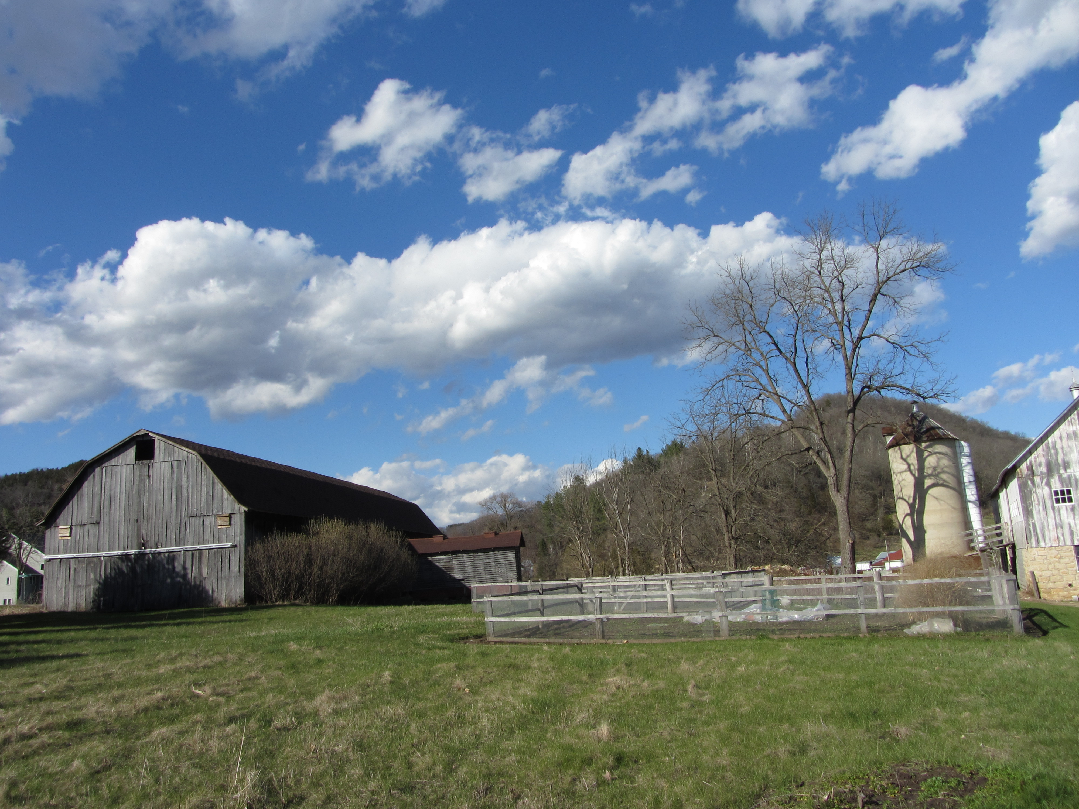

Spring Time In The Valley

Water
Of
Life

27 April 2025

W A T E R O F L I F E

Independent Christian Church—Conservative Lutheran Doctrine

Worship Service: 9:30 a.m.

Larry Cooper, Pastor E-Mail address:
lcooper@wateroflife.cc
Web Site:
www.wateroflife.cc

* * * * * * * * * * * * * * * * * * * * * * * * * * *

Sermon Text: Acts 17:16-34

Paul At Athens

* * * * * * * * * * * * * * * * * * * * * * * * * * *

22 Then Paul stood in the midst of Mars' hill, and said, Ye men of Athens, I perceive that in all things ye are too superstitious.
23 For as I passed by, and beheld your devotions, I found an altar with this inscription, TO THE UNKNOWN GOD. Whom therefore ye ignorantly worship, him declare I unto you.
24 God that made the world and all things therein, seeing that he is Lord of heaven and earth, dwelleth not in temples made with hands;
25 Neither is worshipped with men's hands, as though he needed any thing, seeing he giveth to all life, and breath, and all things;
26 And hath made of one blood all nations of men for to dwell on all the face of the earth, and hath determined the times before appointed, and the bounds of their habitation;
27 That they should seek the Lord, if haply they might feel after him, and find him, though he be not far from every one of us:
28 For in him we live, and move, and have our being; as certain also of your own poets have said, For we are also his offspring.

